ITEC 204 – Data Structures and Algorithms
Name: Gonzales, Aragon Martin B. | Date: 9/24/2026
Section: BSIT - 2A | Instructor: Nuela Maxyne

Objective: Write a short explanation of what your program is designed to do. (Minimum of 3 sentences)

Answer: The objective of this program is to create an IT Automation Incident Ticket Manager that can store and manage incident tickets generated by automation bots. The program allows the user to add, display, search, remove, and count active incident tickets using a Python list. This activity demonstrates how a linear data structure can be applied to a practical IT-related scenario.

Program Operations: Briefly explain how your program performs each operation. (Insert Specific Code Line and Your Explanation)

Add Incident: incident_tickets.append(new_ticket)

Explanation:
The append() function adds the new incident ticket to the end of the incident_tickets list. The new ticket contains the Incident ID, Bot, and Short Description entered by the user.
Display Incidents: for ticket in incident_tickets:

Explanation:
The for loop goes through each incident ticket stored in the list. It displays the Incident ID, Bot, and Short Description of every active incident ticket.

Search Incident: if ticket["incident_id"].lower() == incident_id.lower():

Explanation:
This statement compares the Incident ID entered by the user with the Incident ID stored in each ticket. The .lower() function makes the comparison case-insensitive, allowing the user to search using uppercase or lowercase letters.
Remove Resolved Incident: incident_tickets.remove(ticket)

Explanation:
The remove() function removes the selected incident ticket from the list once its Incident ID is found. This represents removing an incident that has already been resolved.
Count Active Incidents: total = len(incident_tickets)

Explanation:
The len() function determines the number of incident tickets currently stored in the list. This gives the total number of active incident tickets.

Flowchart: Create a flowchart showing the overall process and logic of your program.
Z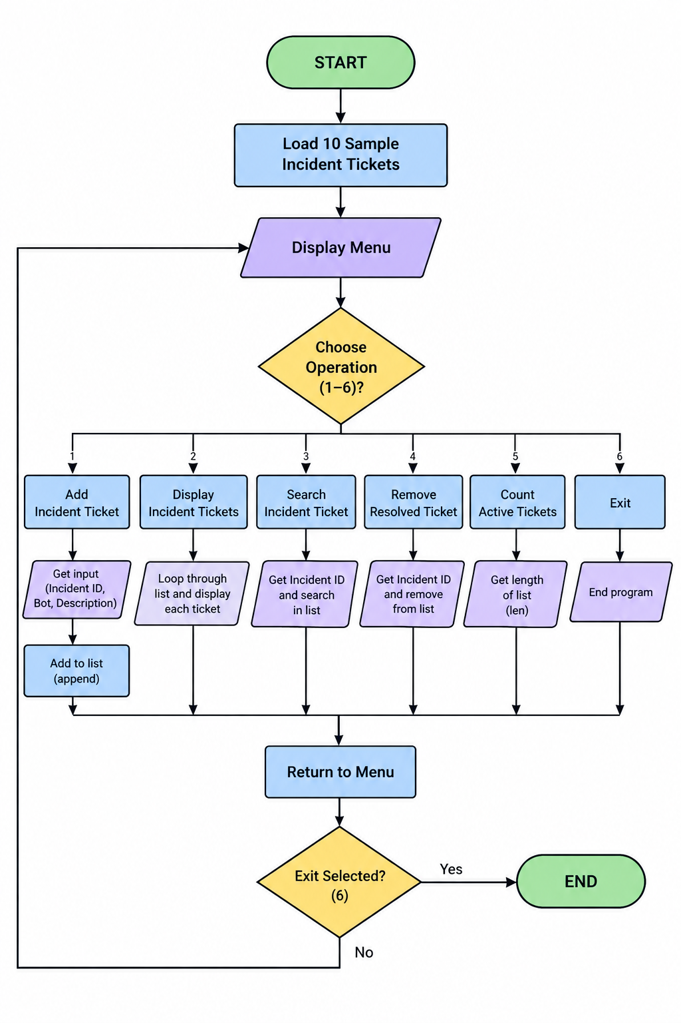

- Conclusion: Briefly explain what you learned from the activity and how the linear data structure was applied.

This activity helped me understand how a linear data structure can be used to manage data in a practical IT scenario. I learned how to use a Python list to add, display, search, remove, and count incident tickets. The activity also showed me how basic data structure operations can be applied to create a simple incident ticket management system.

